Parallel Planes

Definition
# Source: AI Source: Provided by: [Data Path: Persons Table -> ID Column: 1, Name_En Column: Motasem Essam] -> From: [ChatGPT] on [7/25/2026]
Parallel planes are two distinct planes in three-dimensional space that never intersect, no matter how far they extend. The perpendicular distance between them is constant at every point.
In Euclidean solid geometry, parallel planes have normal vectors that point in the same or opposite directions. Their equations have proportional coefficients for $x$, $y$, and $z$, but different constant terms after the equations are normalized.
For example, the planes
$$P_{1}:z=2$$
$$P_{2}:z=6$$
are parallel because both are horizontal planes, but they lie at different heights.
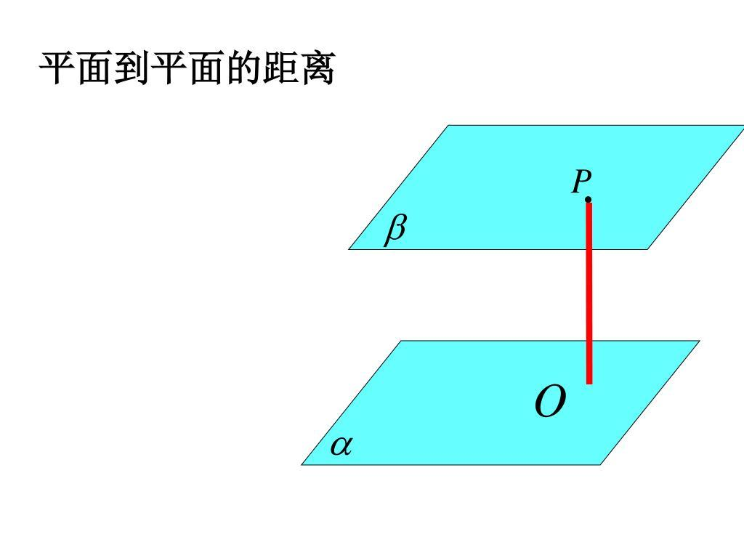
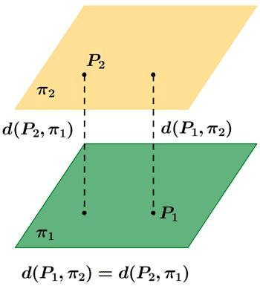
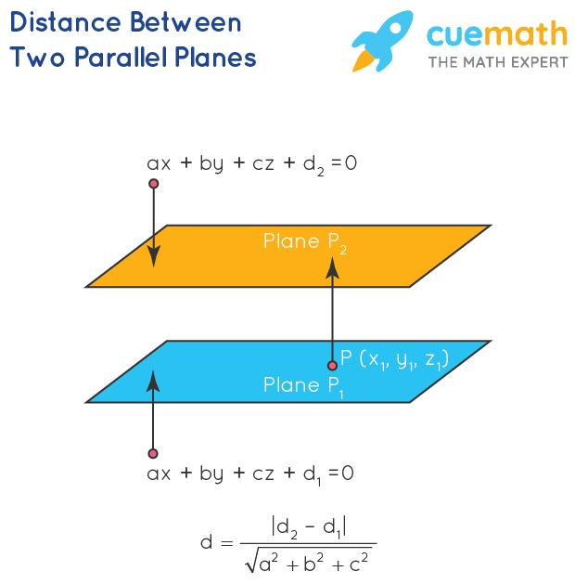

Simple Definition
# Source: AI Source: Provided by: [Data Path: Persons Table -> ID Column: 1, Name_En Column: Motasem Essam] -> From: [ChatGPT] on [7/25/2026]
Parallel planes are flat surfaces in 3D space that remain the same distance apart and never meet.
Examples from everyday life include:
- The floor and ceiling of a rectangular room, when idealized as flat planes.
- Opposite faces of a rectangular box.
- Two horizontal shelves that are level with each other.
These are physical approximations of mathematical planes, which extend infinitely in every direction.

Key Characteristics
# Source: AI Source: Provided by: [Data Path: Persons Table -> ID Column: 1, Name_En Column: Motasem Essam] -> From: [ChatGPT] on [7/25/2026]
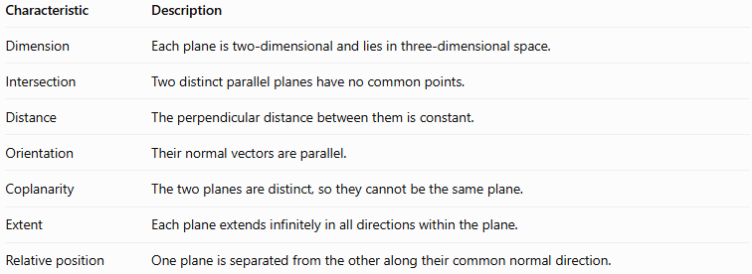
Characteristic | Description
Dimension | Each plane is two-dimensional and lies in three-dimensional space.
Intersection | Two distinct parallel planes have no common points.
Distance | The perpendicular distance between them is constant.
Orientation | Their normal vectors are parallel.
Coplanarity | The two planes are distinct, so they cannot be the same plane.
Extent | Each plane extends infinitely in all directions within the plane.
Relative position | One plane is separated from the other along their common normal direction.

Geometric Representation
# Source: AI Source: Provided by: [Data Path: Persons Table -> ID Column: 1, Name_En Column: Motasem Essam] -> From: [ChatGPT] on [7/25/2026]
Consider two horizontal parallel planes, $P_{1}$ and $P_{2}$, positioned at different heights.
Two distinct planes separated by a constant perpendicular distance.
The dashed line represents the shortest distance between the planes. It meets both planes at right angles.

Mathematical Representation

General equations of two planes
# Source: AI Source: Provided by: [Data Path: Persons Table -> ID Column: 1, Name_En Column: Motasem Essam] -> From: [ChatGPT] on [7/25/2026]
A plane in three-dimensional Cartesian coordinates can be written as
$$P_{1}:A_{1}x+B_{1}y+C_{1}z+D_{1}=0$$
$$P_{2}:A_{2}x+B_{2}y+C_{2}z+D_{2}=0$$
Their normal vectors are
$$n_{1}=\left(A_{1},B_{1},C_{1}\right)$$
$$n_{2}=\left(A_{2},B_{2},C_{2}\right)$$
The planes are parallel when their normal vectors are proportional:
$$n_{2}=kn_{1}$$
for some nonzero constant $k$.
Therefore,
$$A_{2}=kA_{1}, B_{2}=kB_{1}, C_{2}=kC_{1}$$
For the planes to be distinct and parallel, their constant terms must not follow the same proportional relationship. Otherwise, the equations describe the same plane.

Distance between parallel planes
# Source: AI Source: Provided by: [Data Path: Persons Table -> ID Column: 1, Name_En Column: Motasem Essam] -> From: [ChatGPT] on [7/25/2026]
Suppose the planes have the same coefficients for $x$, $y$, and $z$:
$$P_{1}:Ax+By+Cz+D_{1}=0$$
$$P_{2}:Ax+By+Cz+D_{2}=0$$
The perpendicular distance between them is
$$\boxed{d=\frac{\left|D_{2}-D_{1}\right|}{\sqrt{A^{2}+B^{2}+C^{2}}}}$$
Here:
- $d$ is the perpendicular distance.
- $A,B,C$ are the common normal-vector coefficients.
- $D_{1},D_{2}$ are the constant terms.
The absolute value ensures that the distance is nonnegative.

Example using horizontal planes
# Source: AI Source: Provided by: [Data Path: Persons Table -> ID Column: 1, Name_En Column: Motasem Essam] -> From: [ChatGPT] on [7/25/2026]
Consider
$$P_{1}:z=2, P_{2}:z=6$$
Their normal vectors are both $\left(0,0,1\right)$, so the planes are parallel.
The distance between them is
$$d=\left|6-2\right|=\boxed{4}$$
The planes are four units apart.

Worked Examples
# Source: AI Source: Provided by: [Data Path: Persons Table -> ID Column: 1, Name_En Column: Motasem Essam] -> From: [ChatGPT] on [7/25/2026]
Example 1: Identifying parallel planes
Determine whether the following planes are parallel:
$$P_{1}:2x+3y-z+4=0$$
$$P_{2}:4x+6y-2z-10=0$$
Step 1: Identify their normal vectors.
$$n_{1}=\left(2,3,-1\right)$$
$$n_{2}=\left(4,6,-2\right)$$
Step 2: Compare the coefficients.
$$n_{2}=2n_{1}$$
The normal vectors are proportional, so the planes are parallel or coincident.
Step 3: Check whether they are the same plane.
Multiplying the first equation by $2$ gives
$$4x+6y-2z+8=0$$
This differs from the second equation, whose constant term is $-10$.
Conclusion: The planes are distinct and parallel.
Example 2: Calculating the distance
Find the distance between
$$P_{1}:3x+4y+12z-5=0$$
$$P_{2}:3x+4y+12z+21=0$$
Using the distance formula,
$$d=\frac{\left|21-\left(-5\right)\right|}{\sqrt{3^{2}+4^{2}+{12}^{2}}}$$
$$d=\frac{26}{\sqrt{9+16+144}}$$
$$d=\frac{26}{13}=\boxed{2}$$
Answer: The perpendicular distance is $2$ units.
Example 3: Planes parallel to a coordinate plane
Consider
$$P_{1}:y=3, P_{2}:y=-2$$
Both planes are parallel to the $xz$-plane because their $y$-coordinates are constant.
Their separation is
$$d=\left|3-\left(-2\right)\right|=\boxed{5}$$

Comparison with Related Concepts
# Source: AI Source: Provided by: [Data Path: Persons Table -> ID Column: 1, Name_En Column: Motasem Essam] -> From: [ChatGPT] on [7/25/2026]
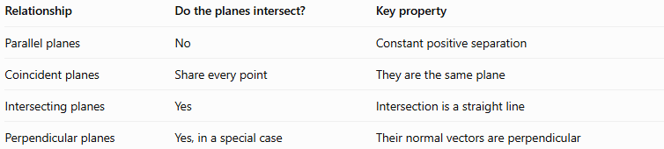
Relationship | Do the planes intersect? | Key property
Parallel planes | No | Constant positive separation
Coincident planes | Share every point | They are the same plane
Intersecting planes | Yes | Intersection is a straight line
Perpendicular planes | Yes, in a special case | Their normal vectors are perpendicular
Important distinction: Perpendicular planes are a type of intersecting planes. Distinct parallel planes never intersect in Euclidean geometry.

Applications
# Source: AI Source: Provided by: [Data Path: Persons Table -> ID Column: 1, Name_En Column: Motasem Essam] -> From: [ChatGPT] on [7/25/2026]

Architecture and construction
Floors, ceilings, and level shelves can be modeled as parallel planes to study spacing and alignment.
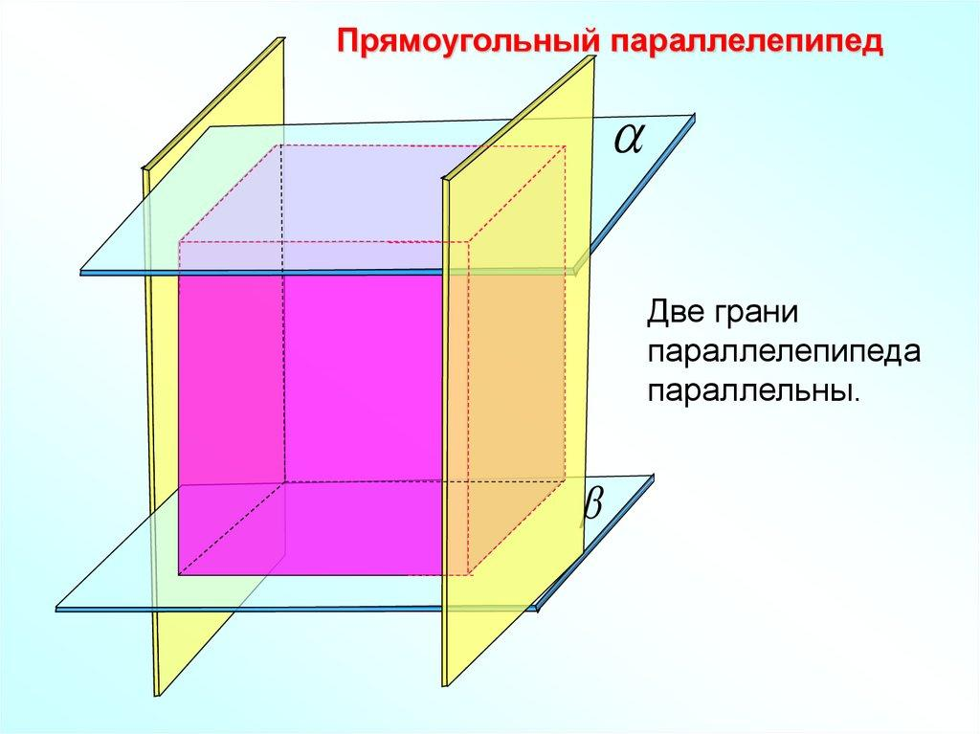
Three-dimensional shapes
Opposite faces of a rectangular cuboid are parallel planes, making them useful for studying solid geometry.
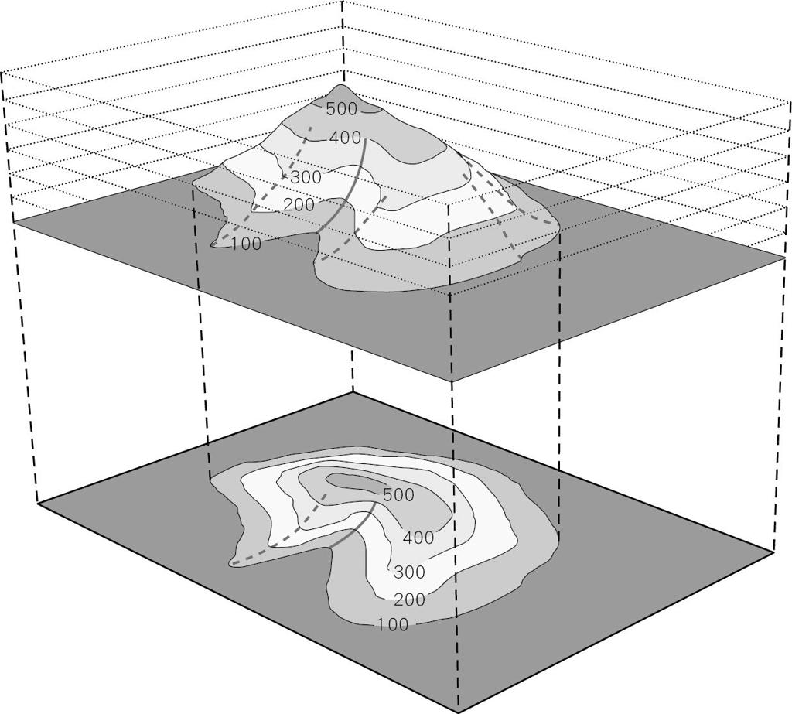
Engineering and modeling
Parallel reference surfaces help define clearances, offsets, and layers in three-dimensional designs.

Key Points
# Source: AI Source: Provided by: [Data Path: Persons Table -> ID Column: 1, Name_En Column: Motasem Essam] -> From: [ChatGPT] on [7/25/2026]
- Parallel planes are distinct planes that never intersect.
- Their perpendicular distance remains constant.
- Their normal vectors are proportional.
- Proportional normal vectors alone are not sufficient to prove that two planes are distinct; coincident planes must also be ruled out.
- For planes with identical $A,B,C$ coefficients, use
$$d=\frac{\left|D_{2}-D_{1}\right|}{\sqrt{A^{2}+B^{2}+C^{2}}}$$
- Opposite faces of a rectangular cuboid provide a familiar example.

Conclusion
# Source: AI Source: Provided by: [Data Path: Persons Table -> ID Column: 1, Name_En Column: Motasem Essam] -> From: [ChatGPT] on [7/25/2026]
Parallel planes are a fundamental concept in solid geometry. Their defining properties are non-intersection, proportional normal vectors, and constant perpendicular separation. These properties allow us to identify parallel planes from their equations and calculate the distance between them.

